SPARK 2026 | Breast Lesion Segmentation Challenge
Build a U-Net from scratch in PyTorch to segment breast tumours from ultrasound images

Overview

SPARK Academy 2026 | Breast Lesion Segmentation Challenge
Welcome to the SPARK Academy 2026 | Breast Lesion Segmentation Challenge.
Skilled radiologists are scarce across Sub-Saharan Africa, yet breast ultrasound scans are widely available. Your task is to build a model that segments breast lesions from ultrasound images — pixel by pixel — giving clinicians an automated tool for tumour localisation and measurement.
Goal: Build a breast lesion segmentation model from scratch in PyTorch. Start from U-Net, modify it, research improvements, and push your Dice score as high as you can.
Metric: Mean Dice Coefficient on the held-out test set.
Submission: A .csv file with image_id and rle_mask columns, plus a PDF summary and notebook emailed to spark@cameramriafrica.org. See the Rules tab for full details.

Description

The Problem
Breast cancer kills over 670,000 women annually. In Africa, radiologists are scarce — yet ultrasound machines are not. Your task: build an AI model that segments breast tumours from ultrasound images, pixel by pixel.

The Task
Binary semantic segmentation. Given a breast ultrasound image, predict a mask where 1 = lesion and 0 = background.
Scored using mean Dice Coefficient:
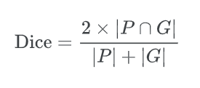

The Dataset
A curated combination of BUSI and BUS-BRA — two publicly available, expert-annotated breast ultrasound datasets. Deduplicated, standardised, and split into train, val, and test sets.
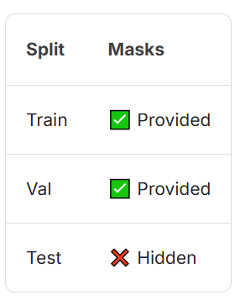

What You Must Do
- Implement U-Net from scratch in PyTorch as your baseline
- Modify the architecture, experiment with loss functions and augmentations
- Research improvements from the literature and apply them
- Document everything in your notebook
Pre-trained encoders and segmentation libraries are not permitted.

Submission Format
A .csv file with two columns: image_id (e.g. sp_test_0001.png) and rle_mask (run-length encoded prediction). Use sample_submission.csv as your template.

Dataset Citations
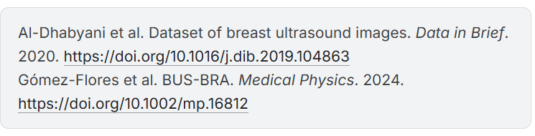

Evaluation
Submissions are evaluated on the mean Dice Coefficient between the predicted mask and the ground truth mask across all test images.
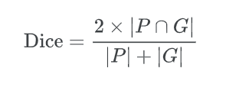
A score of 1.0 is a perfect prediction. A score of 0.0 means no overlap. The public leaderboard is scored on 50% of the test images. Final rankings are based on the remaining 50% revealed after the deadline.

Submission File
For each image in the test set, predict a run-length encoded binary mask. The file should contain a header and have the following format:
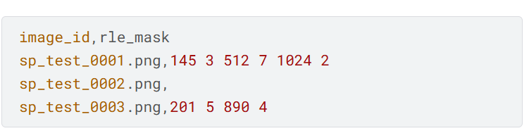
- image_id must match the test image filenames exactly
- rle_mask is the predicted mask encoded as start length pairs in column-major (Fortran) order
- If your model predicts no lesion for an image, leave rle_mask empty
Download sample_submission.csv from the Data tab to use as your template.

